https://docs.microsoft.com/en-us/learn/modules/intro-to-azure-fundamentals/what-is-microsoft-azure

Exam AZ-900: Microsoft Azure Fundamentals .--For Azure Fundamentals

AZ-900 Domain Area Weight

Describe cloud concepts 20-25%

Describe core Azure services 15-20%

Describe core solutions and management tools on Azure 10-15%

Describe general security and network security features 10-15%

Describe identity, governance, privacy, and compliance features 20-25%

Describe Azure cost management and Service Level Agreements 10-15%

The following illustration demonstrates the services that might run in each of the cloud service models.

[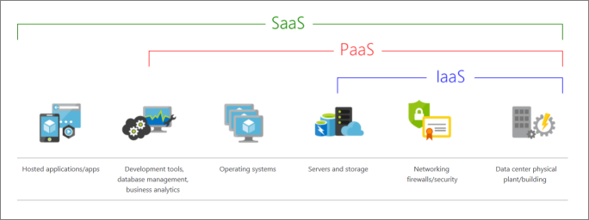](https://docs.microsoft.com/en-us/learn/azure-fundamentals/intro-to-azure-fundamentals/media/iaas-paas-saas-expanded.png#lightbox)

The following chart illustrates the various levels of responsibility between a cloud provider and a cloud tenant.

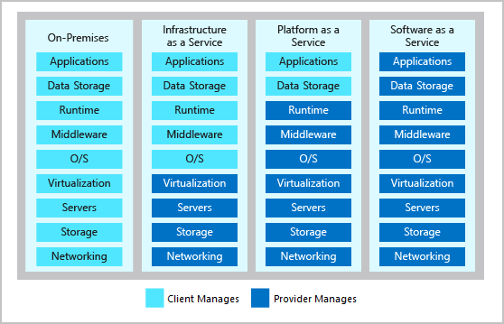

**Azure services**

Here's a big-picture view of the available services and features in Azure.

[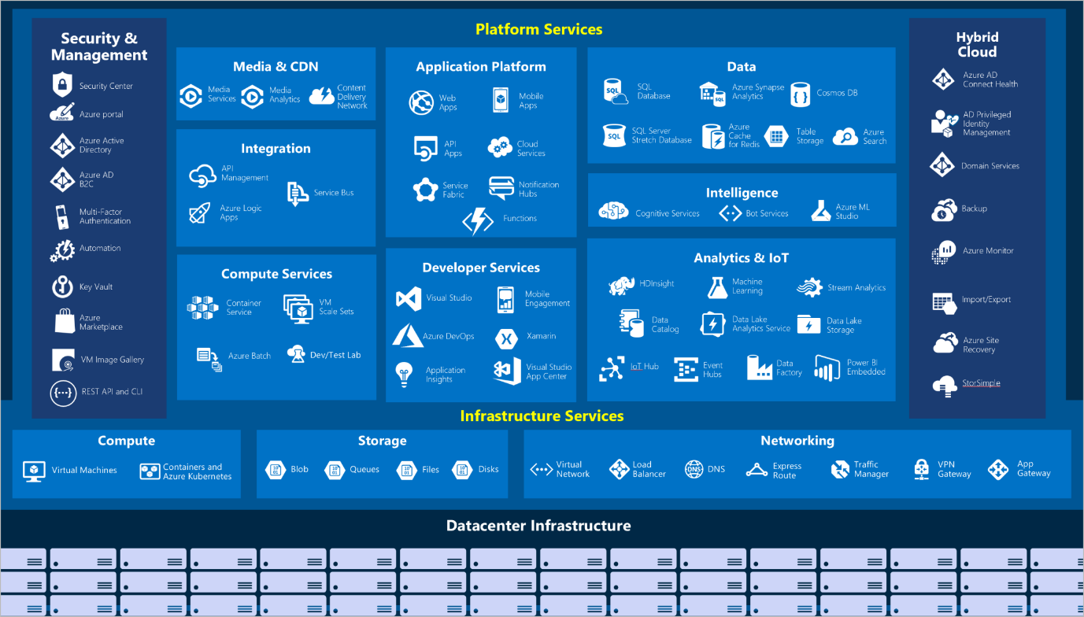](https://docs.microsoft.com/en-us/learn/azure-fundamentals/intro-to-azure-fundamentals/media/azure-services.png#lightbox)

Let's take a closer look at the most commonly used categories:

* Compute
* Networking
* Storage
* Mobile
* Databases
* Web
* Internet of Things (IoT)
* Big data
* AI

### Compute

Compute services are often one of the primary reasons why companies move to the Azure platform. Azure provides a range of options for hosting applications and services. Here are some examples of compute services in Azure.

| **TABLE 1** | |
| --- | --- |
| **Service name** | **Service function** |
| Azure Virtual Machines | Windows or Linux virtual machines (VMs) hosted in Azure. |
| Azure Virtual Machine Scale Sets | Scaling for Windows or Linux VMs hosted in Azure. |
| Azure Kubernetes Service | Cluster management for VMs that run containerized services. |
| Azure Service Fabric | Distributed systems platform that runs in Azure or on-premises. |
| Azure Batch | Managed service for parallel and high-performance computing applications. |
| Azure Container Instances | Containerized apps run on Azure without provisioning servers or VMs. |
| Azure Functions | An event-driven, serverless compute service. |

### Networking

Linking compute resources and providing access to applications is the key function of Azure networking. Networking functionality in Azure includes a range of options to connect the outside world to services and features in the global Azure datacenters.

Here are some examples of networking services in Azure.

| **TABLE 2** | |
| --- | --- |
| **Service name** | **Service function** |
| Azure Virtual Network | Connects VMs to incoming virtual private network (VPN) connections. |
| Azure Load Balancer | Balances inbound and outbound connections to applications or service endpoints. |
| Azure Application Gateway | Optimizes app server farm delivery while increasing application security. |
| Azure VPN Gateway | Accesses Azure Virtual Networks through high-performance VPN gateways. |
| Azure DNS | Provides ultra-fast DNS responses and ultra-high domain availability. |
| Azure Content Delivery Network | Delivers high-bandwidth content to customers globally. |
| Azure DDoS Protection | Protects Azure-hosted applications from distributed denial of service (DDOS) attacks. |
| Azure Traffic Manager | Distributes network traffic across Azure regions worldwide. |
| Azure ExpressRoute | Connects to Azure over high-bandwidth dedicated secure connections. |
| Azure Network Watcher | Monitors and diagnoses network issues by using scenario-based analysis. |
| Azure Firewall | Implements high-security, high-availability firewall with unlimited scalability. |
| Azure Virtual WAN | Creates a unified wide area network (WAN) that connects local and remote sites. |

### Storage

Azure provides four main types of storage services.

| **TABLE 3** | |
| --- | --- |
| **Service name** | **Service function** |
| Azure Blob storage | Storage service for very large objects, such as video files or bitmaps. |
| Azure File storage | File shares that can be accessed and managed like a file server. |
| Azure Queue storage | A data store for queuing and reliably delivering messages between applications. |
| Azure Table storage | A NoSQL store that hosts unstructured data independent of any schema. |

These services all share several common characteristics:

* **Durable** and highly available with redundancy and replication.
* **Secure** through automatic encryption and role-based access control.
* **Scalable** with virtually unlimited storage.
* **Managed**, handling maintenance and any critical problems for you.
* **Accessible** from anywhere in the world over HTTP or HTTPS.

### Mobile

With Azure, developers can create mobile back-end services for iOS, Android, and Windows apps quickly and easily. Features that used to take time and increase project risks, such as adding corporate sign-in and then connecting to on-premises resources such as SAP, Oracle, SQL Server, and SharePoint, are now simple to include.

Other features of this service include:

* Offline data synchronization.
* Connectivity to on-premises data.
* Broadcasting push notifications.
* Autoscaling to match business needs.

### Databases

Azure provides multiple database services to store a wide variety of data types and volumes. And with global connectivity, this data is available to users instantly.

| **TABLE 4** | |
| --- | --- |
| **Service name** | **Service function** |
| Azure Cosmos DB | Globally distributed database that supports NoSQL options. |
| Azure SQL Database | Fully managed relational database with auto-scale, integral intelligence, and robust security. |
| Azure Database for MySQL | Fully managed and scalable MySQL relational database with high availability and security. |
| Azure Database for PostgreSQL | Fully managed and scalable PostgreSQL relational database with high availability and security. |
| SQL Server on Azure Virtual Machines | Service that hosts enterprise SQL Server apps in the cloud. |
| Azure Synapse Analytics | Fully managed data warehouse with integral security at every level of scale at no extra cost. |
| Azure Database Migration Service | Service that migrates databases to the cloud with no application code changes. |
| Azure Cache for Redis | Fully managed service caches frequently used and static data to reduce data and application latency. |
| Azure Database for MariaDB | Fully managed and scalable MariaDB relational database with high availability and security. |

### Web

Having a great web experience is critical in today's business world. Azure includes first-class support to build and host web apps and HTTP-based web services. The following Azure services are focused on web hosting.

| **TABLE 5** | |
| --- | --- |
| **Service name** | **Description** |
| Azure App Service | Quickly create powerful cloud web-based apps. |
| Azure Notification Hubs | Send push notifications to any platform from any back end. |
| Azure API Management | Publish APIs to developers, partners, and employees securely and at scale. |
| Azure Cognitive Search | Deploy this fully managed search as a service. |
| Web Apps feature of Azure App Service | Create and deploy mission-critical web apps at scale. |
| Azure SignalR Service | Add real-time web functionalities easily. |

### IoT

People are able to access more information than ever before. Personal digital assistants led to smartphones, and now there are smart watches, smart thermostats, and even smart refrigerators. Personal computers used to be the norm. Now the internet allows any item that's online-capable to access valuable information. This ability for devices to garner and then relay information for data analysis is referred to as IoT.

Many services can assist and drive end-to-end solutions for IoT on Azure.

| **TABLE 6** | |
| --- | --- |
| **Service name** | **Description** |
| IoT Central | Fully managed global IoT software as a service (SaaS) solution that makes it easy to connect, monitor, and manage IoT assets at scale. |
| Azure IoT Hub | Messaging hub that provides secure communications between and monitoring of millions of IoT devices. |
| IoT Edge | Fully managed service that allows data analysis models to be pushed directly onto IoT devices, which allows them to react quickly to state changes without needing to consult cloud-based AI models. |

### Big data

Data comes in all formats and sizes. When we talk about big data, we're referring to large volumes of data. Data from weather systems, communications systems, genomic research, imaging platforms, and many other scenarios generate hundreds of gigabytes of data. This amount of data makes it hard to analyze and make decisions. It's often so large that traditional forms of processing and analysis are no longer appropriate.

Open-source cluster technologies have been developed to deal with these large data sets. Azure supports a broad range of technologies and services to provide big data and analytic solutions.

| **TABLE 7** | |
| --- | --- |
| **Service name** | **Description** |
| Azure Synapse Analytics | Run analytics at a massive scale by using a cloud-based enterprise data warehouse that takes advantage of massively parallel processing to run complex queries quickly across petabytes of data. |
| Azure HDInsight | Process massive amounts of data with managed clusters of Hadoop clusters in the cloud. |
| Azure Databricks | Integrate this collaborative Apache Spark-based analytics service with other big data services in Azure. |

### AI

AI, in the context of cloud computing, is based around a broad range of services, the core of which is machine learning. Machine learning is a data science technique that allows computers to use existing data to forecast future behaviors, outcomes, and trends. Using machine learning, computers learn without being explicitly programmed.

Forecasts or predictions from machine learning can make apps and devices smarter. For example, when you shop online, machine learning helps recommend other products you might like based on what you've purchased. Or when your credit card is swiped, machine learning compares the transaction to a database of transactions and helps detect fraud. And when your robot vacuum cleaner vacuums a room, machine learning helps it decide whether the job is done.

Here are some of the most common AI and machine learning service types in Azure.

| **TABLE 8** | |
| --- | --- |
| **Service name** | **Description** |
| Azure Machine Learning Service | Cloud-based environment you can use to develop, train, test, deploy, manage, and track machine learning models. It can auto-generate a model and auto-tune it for you. It will let you start training on your local machine, and then scale out to the cloud. |
| Azure Machine Learning Studio | Collaborative visual workspace where you can build, test, and deploy machine learning solutions by using prebuilt machine learning algorithms and data-handling modules. |

A closely related set of products are the cognitive services. You can use these prebuilt APIs in your applications to solve complex problems.

| **TABLE 9** | |
| --- | --- |
| **Service name** | **Description** |
| Vision | Use image-processing algorithms to smartly identify, caption, index, and moderate your pictures and videos. |
| Speech | Convert spoken audio into text, use voice for verification, or add speaker recognition to your app. |
| Knowledge mapping | Map complex information and data to solve tasks such as intelligent recommendations and semantic search. |
| Bing Search | Add Bing Search APIs to your apps and harness the ability to comb billions of webpages, images, videos, and news with a single API call. |
| Natural Language processing | Allow your apps to process natural language with prebuilt scripts, evaluate sentiment, and learn how to recognize what users want. |

### DevOps

DevOps brings together people, processes, and technology by automating software delivery to provide continuous value to your users. With Azure DevOps, you can create build and release pipelines that provide continuous integration, delivery, and deployment for your applications. You can integrate repositories and application tests, perform application monitoring, and work with build artifacts. You can also work with and backlog items for tracking, automate infrastructure deployment, and integrate a range of third-party tools and services such as Jenkins and Chef. All of these functions and many more are closely integrated with Azure to allow for consistent, repeatable deployments for your applications to provide streamlined build and release processes.

| **TABLE 10** | |
| --- | --- |
| **Service name** | **Description** |
| Azure DevOps | Use development collaboration tools such as high-performance pipelines, free private Git repositories, configurable Kanban boards, and extensive automated and cloud-based load testing. Formerly known as Visual Studio Team Services. |
| Azure DevTest Labs | Quickly create on-demand Windows and Linux environments to test or demo applications directly from deployment pipelines. |

# Get started with Azure accounts

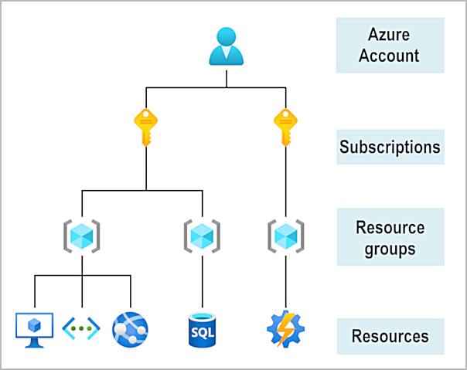

# Case study introduction

* 2 minutes

Throughout the Azure Fundamentals learning paths, we'll work with [Tailwind Traders](https://www.tailwindtraders.com/), a fictitious home improvement retailer. It operates retail hardware stores across the globe and online.

Tailwind Traders currently manages an on-premises datacenter that hosts the company's retail website. The datacenter also stores all of the data and streaming video for its applications. The IT department is currently responsible for all of the management tasks for its computing hardware and software. For example, let's suppose that you work as an IT specialist for the company's IT department. Your IT team handles the procurement process to buy new hardware, installs and configures software, and deploys everything throughout the datacenter.

These management responsibilities create some obstacles for delivering your applications to your users in a timely fashion. As an IT pro, you realize it would be advantageous to have servers, storage, databases, and other services immediately available when you develop and deploy applications. You want to easily start a new server or add services to your solutions.

In the other units of this learning module, you've learned about some of the cloud-based services that Tailwind Traders can use to address its technology challenges. With that in mind, the services that are available through Azure can help Tailwind Traders conduct its business more efficiently.

As you complete the various modules in the Azure Fundamentals learning paths, we'll analyze the challenges that Tailwind Traders is facing. You'll see how you can use Azure services to address each of the issues as they arise. After you've completed each of the modules, the knowledge that you gained from resolving the hypothetical challenges that the fictional Tailwind Traders company encountered should benefit you in your real-world environments.